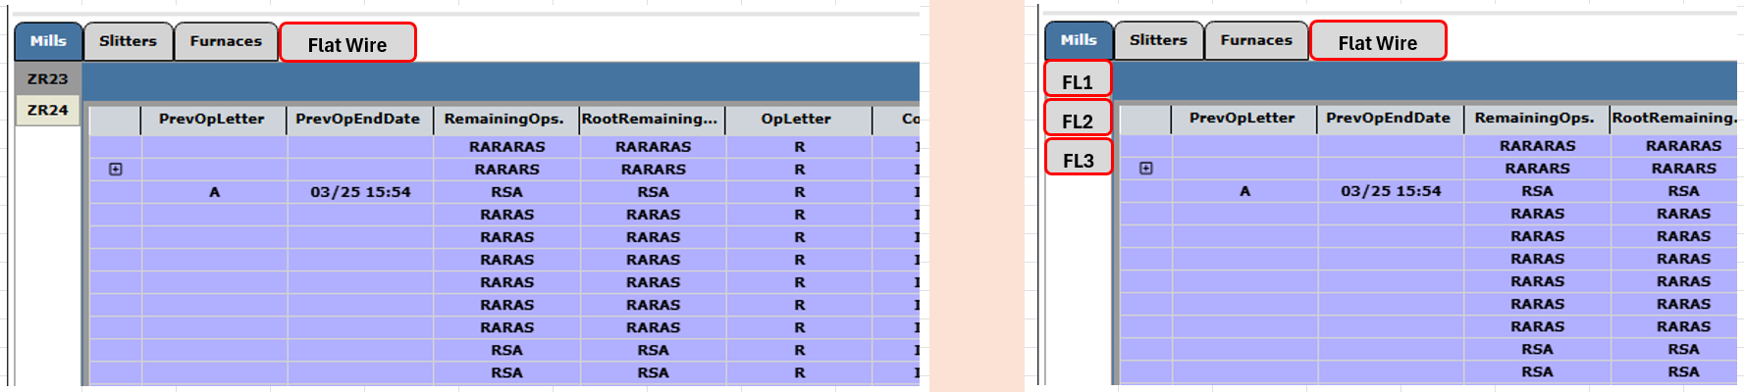

Operation Columns
  - Use “F” for flattening operation in:
    - PrevOpLetter
    - RemainingOps.
    - RootRemainingOps.
    - OpLetter
Add tab for “Flattening Lines”
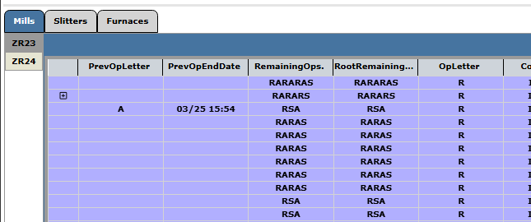
Add machine names to left:
    - “FL1” (Flattening Line 1)
    - “FL2” (Flattening Line 2)
    - “FL3” (Flattening Line 3 (Hybrid Machine includes 1&2))
  - 

Coil Status Column
  - Need to add status for Flattening “INFLAT”
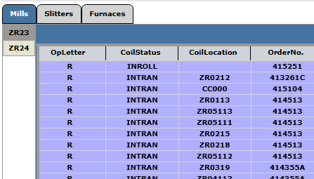
Columns That Need to be Created or Modified:
  - CoilNo Change to “Coil/BundleNo”
  - SlitWidth Change to “Slit/FlatWidth”
  - IsCampaingCoil Change to “IsCampaignCoil/Bundle”
  - CoilLocation Change to “Coil/BundleLocation”
  - MachineId Need to add the three flattening lines and create IdNo for each
  - CoilWeight Change to “Coil/BundleWeight”
  - CoilStatus Change to “Coil/BundleStatus”
  - OutgoingCoilId Change to “OutgoingCoil/BundleId”
  - OutgoingCoilOd Change to “OutgoingCoil/BundleOd”
  - OutgoingCoil/BundleWidth New Column
  - IncomingWireDia New Column

